**Project Progress of Smart Trash Bin**

**Update Function**

1. **System execution process：**
   1. The signal of the **weight sensor as a switch**, the weight beyond the threshold, the camera **automatically takes a capture and record weight**
   2. PC **automatically downloads all captures** from Raspberry Pi
   3. Then, The PC begin to **analyzes all photos**, **predict the categories** and **record weight** of each photo, and **stores them** in a dictionary.
   4. The PC **calculates** the corresponding **carbon dioxide emissions** based on the **accumulated weigh**t and **type**
   5. We designed a GUI, an .exe file, which can display a variety of statistical data (quantity, weight, carbon dioxide emissions, etc.) in the form of a pie chart

**Change of target**

Through communication with Paul, in order to make the neural network work better, Paul changed the use of the project.

1. The **food passes** through the **device** when it is **complete**(haven’t been eaten), at which time the device **records** the predicted **categories** and the corresponding QR code on the plate
2. When the **food is finished,** **return to the device**. At this time, only the **QR code** and **weighed** are recognized.
3. **According to the QR code on the empty plate, find the categories** of food. Through the connection of the QR code, at this point we have **obtained** both the **label and weight**

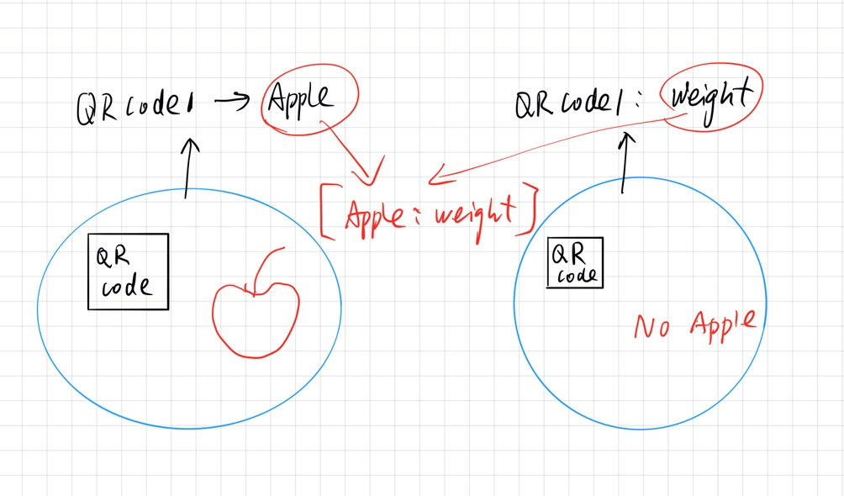

**CNN training**

We have rained the accuracy of CNN to 98% for classifying 24 categories

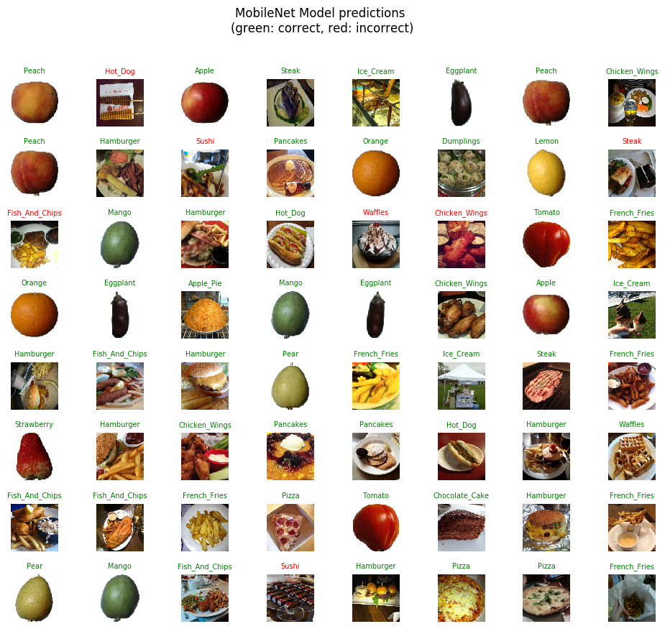

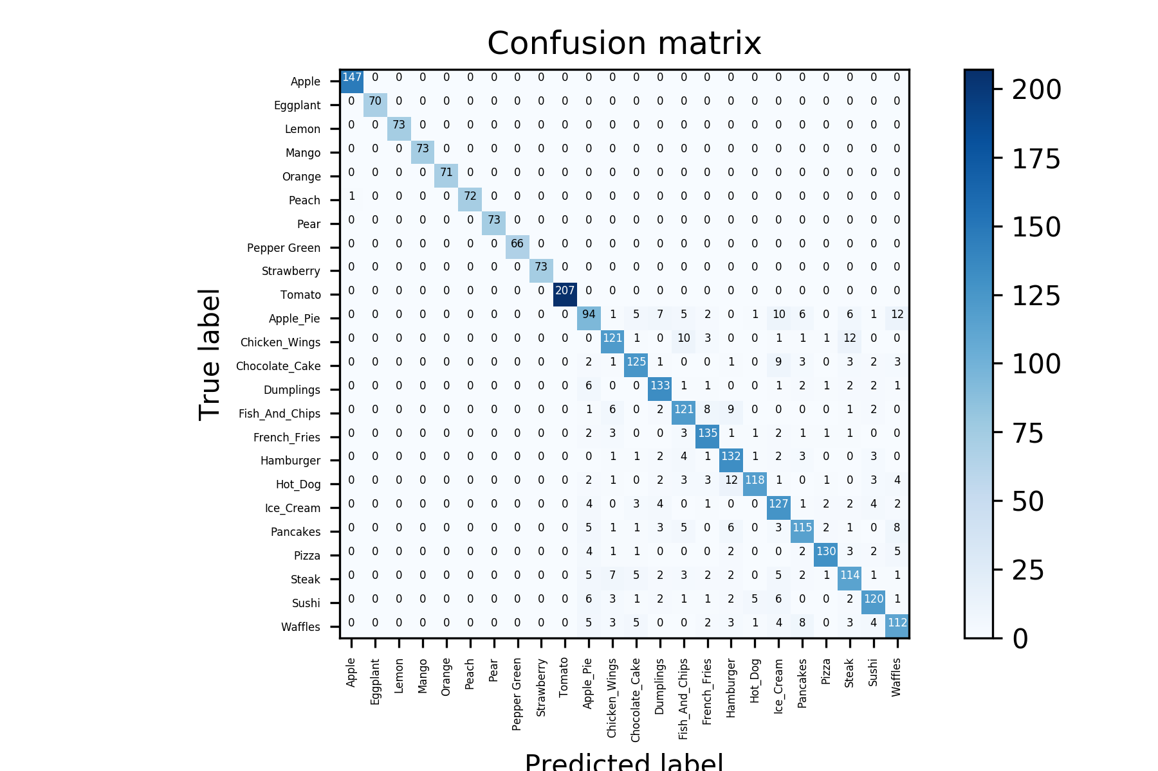

**Confusion matrix**

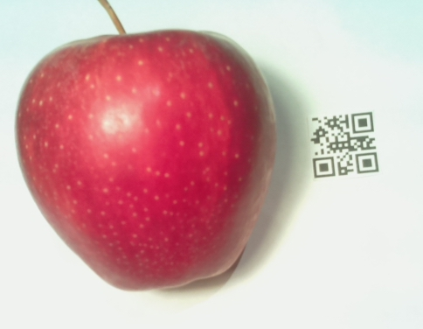**Experimental test**

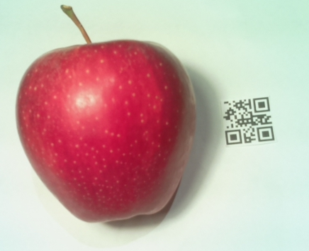

Capture of Rasp PI

analysis of picture above

label: Apple: [count: 1 time, weight 88g, CO2 emission 96.8g]

Here we just took two pictures with Raspberry Pi, but the program can process many pictures in batches.